**Practical No: 08**

**AIM: Acquisition of Cell phones and Mobile devices.**

1. **Download required files.**

(a) MOBILedit! Forensic Software (Desktop/Laptop)  
(b) Forensic Tool apk (Android)

1. **Connect your Device by clicking on “Connection Wizard”.**

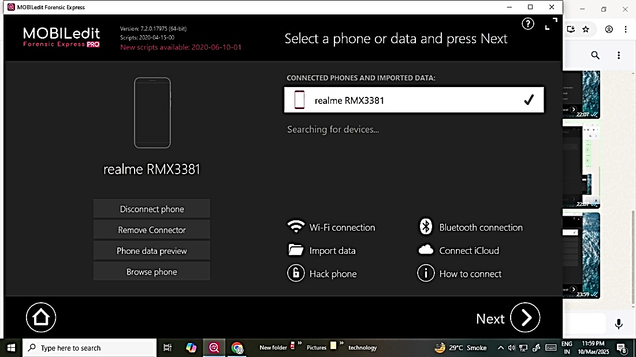

1. **Enable Developer Mode in your Phone and After Developer Mode Enabled -> Enable USB Debugging (developer options).**

1. **Make sure USB Debugging is enabled and you choose to connect with your desktop when confirmation prompts at your phone screen (Tick if required)  
   - Click on USB Tethering (when connected with PC/Laptop).**

1. **After successful connection select the option for what we have to extract -> Specific selection.**

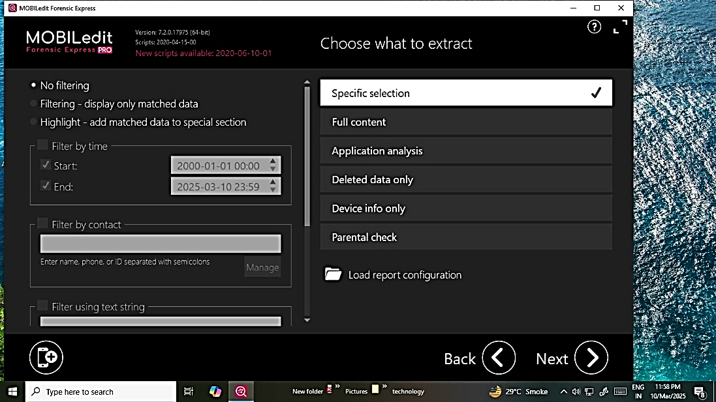

1. **Click on next and select what we have to configure in the report like summary, screenshots, messages, contacts or email etc.**

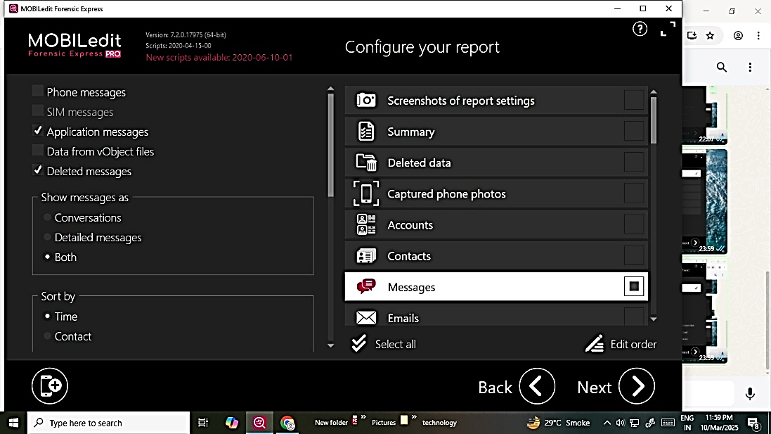

1. **After selection click on next.**

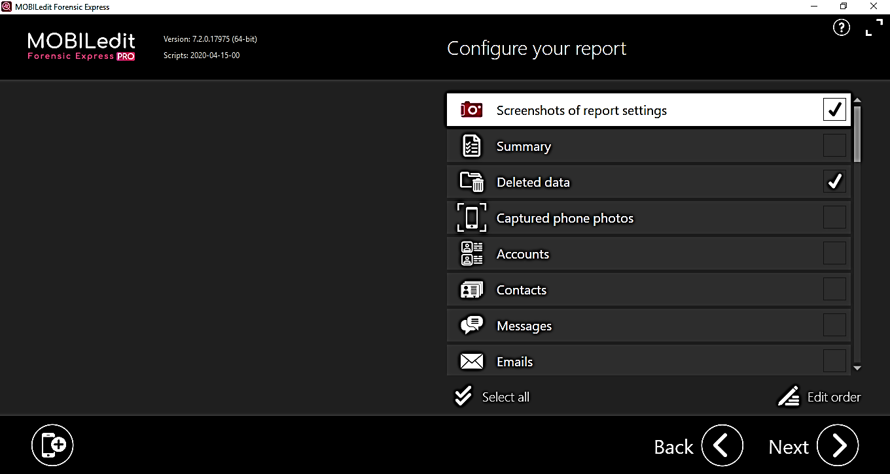

1. **Fill the report details and click on next:**

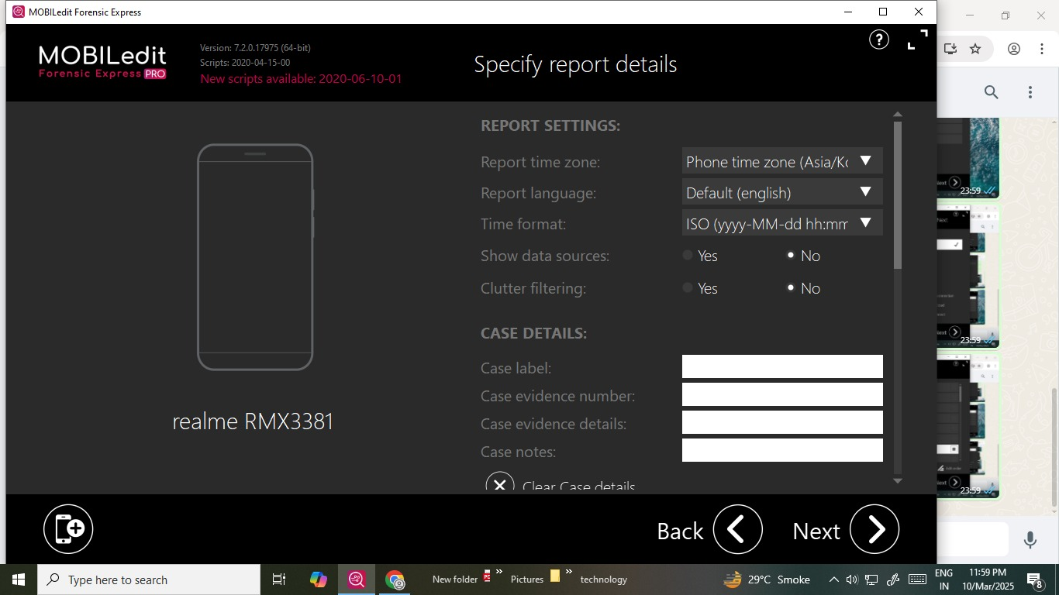

1. **Choose the output format such as HTML report or pdf report and click on next.**

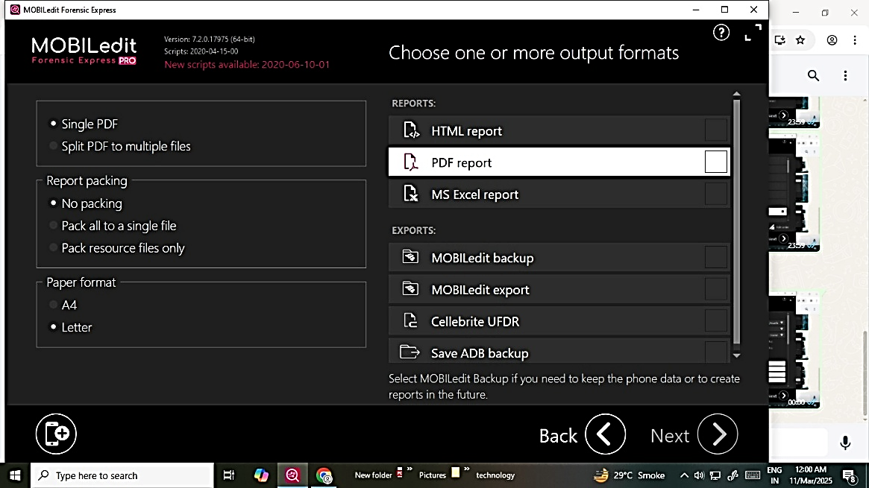

1. **Configure the report destination path and click on Export.**

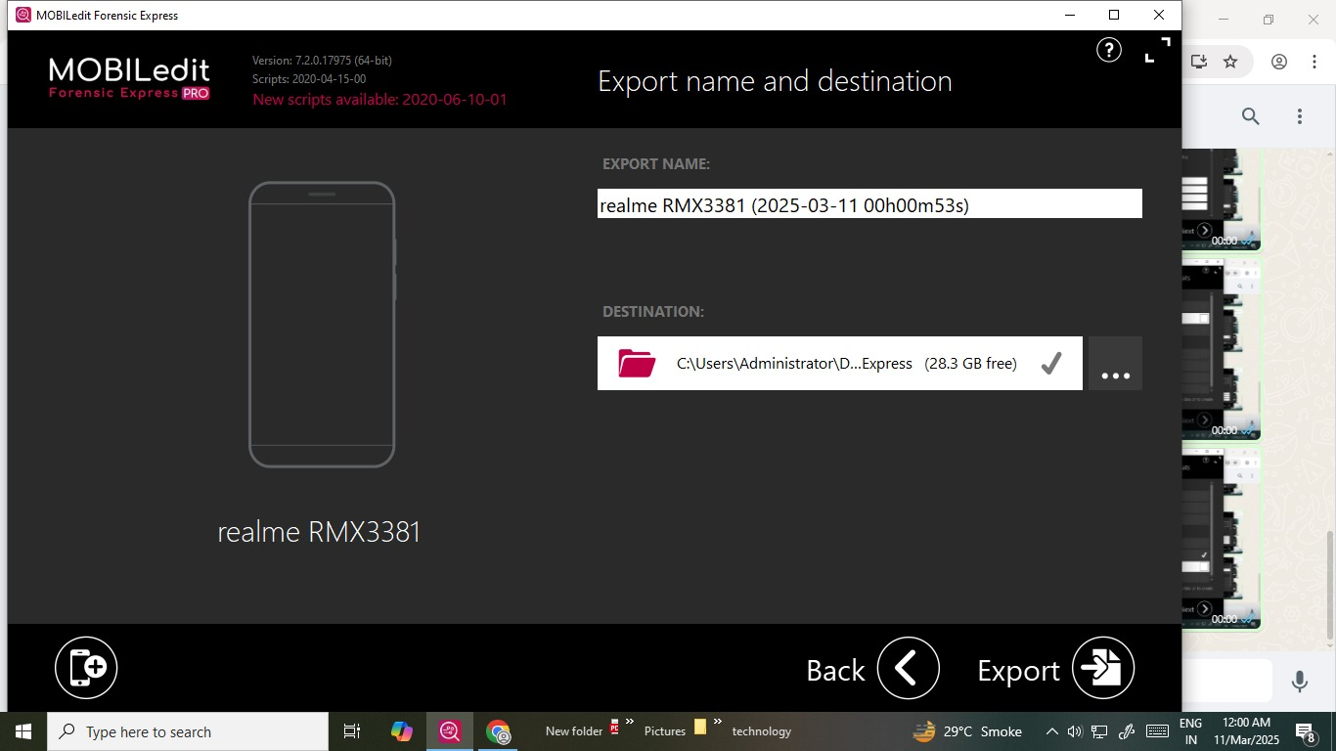

1. **Message will pop up and asking for ready to start backup then click on Ok and in Android device also Allow to backup data.**

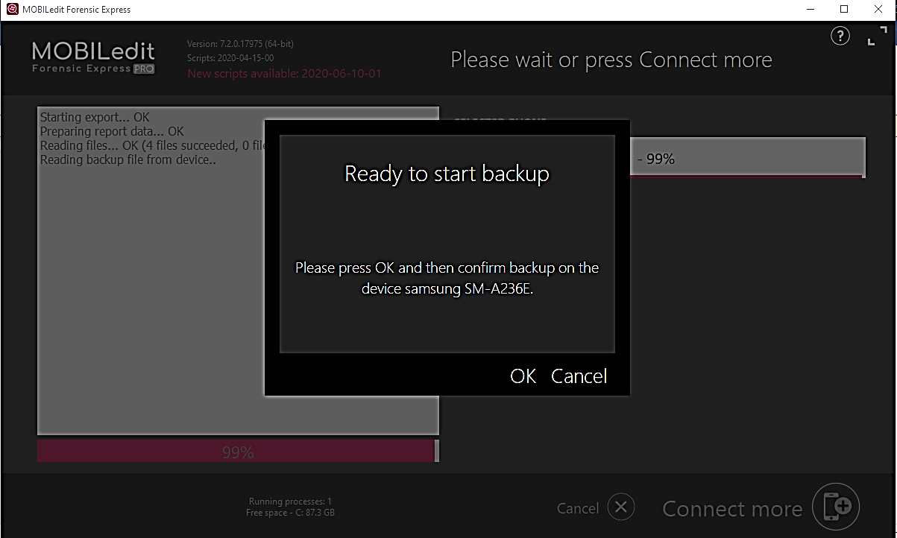

1. **Now the extract will start and complete within few minutes.**

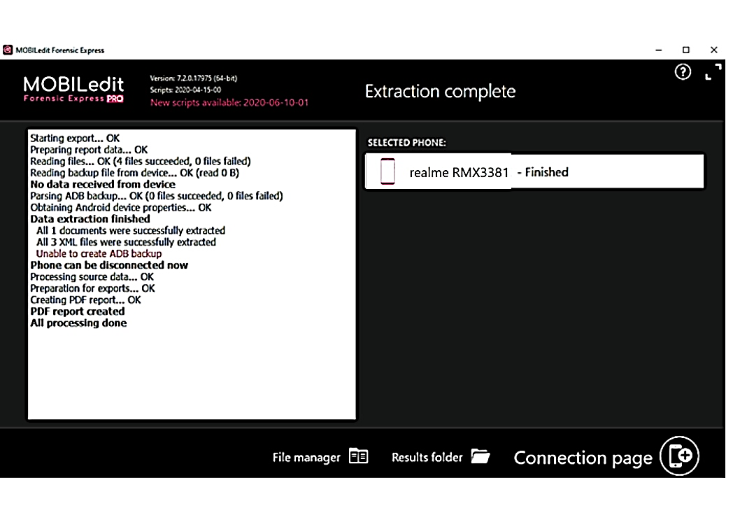

1. **Reports will be generated at the specified destination path.**

